**LARCH PROVISIONS & CATERING**

Larch Provisions is a craft catering company located in Corbett, Oregon. We offer organic prepared meals, food goods and catering services to the Corbett countryside, Columbia Gorge and National Scenic Area.

We specialize in new American farm food, focused intently on locality, Northwest-regional food ways & micro-seasonal ingredients. Inspired by local & global flavors, wild edibles and the bounty of the Pacific Northwest - we aim to provide simple, healthy farm fare & ingredient-driven comfort foods prepared with both classic & modern techniques.

In 2016 we will open a food cart & gathering space on the historic highway. With community and commerce in mind, we look forward to sharing with you the best of our craft kitchen.

**BIOS**

**EMILY CAFAZZO**

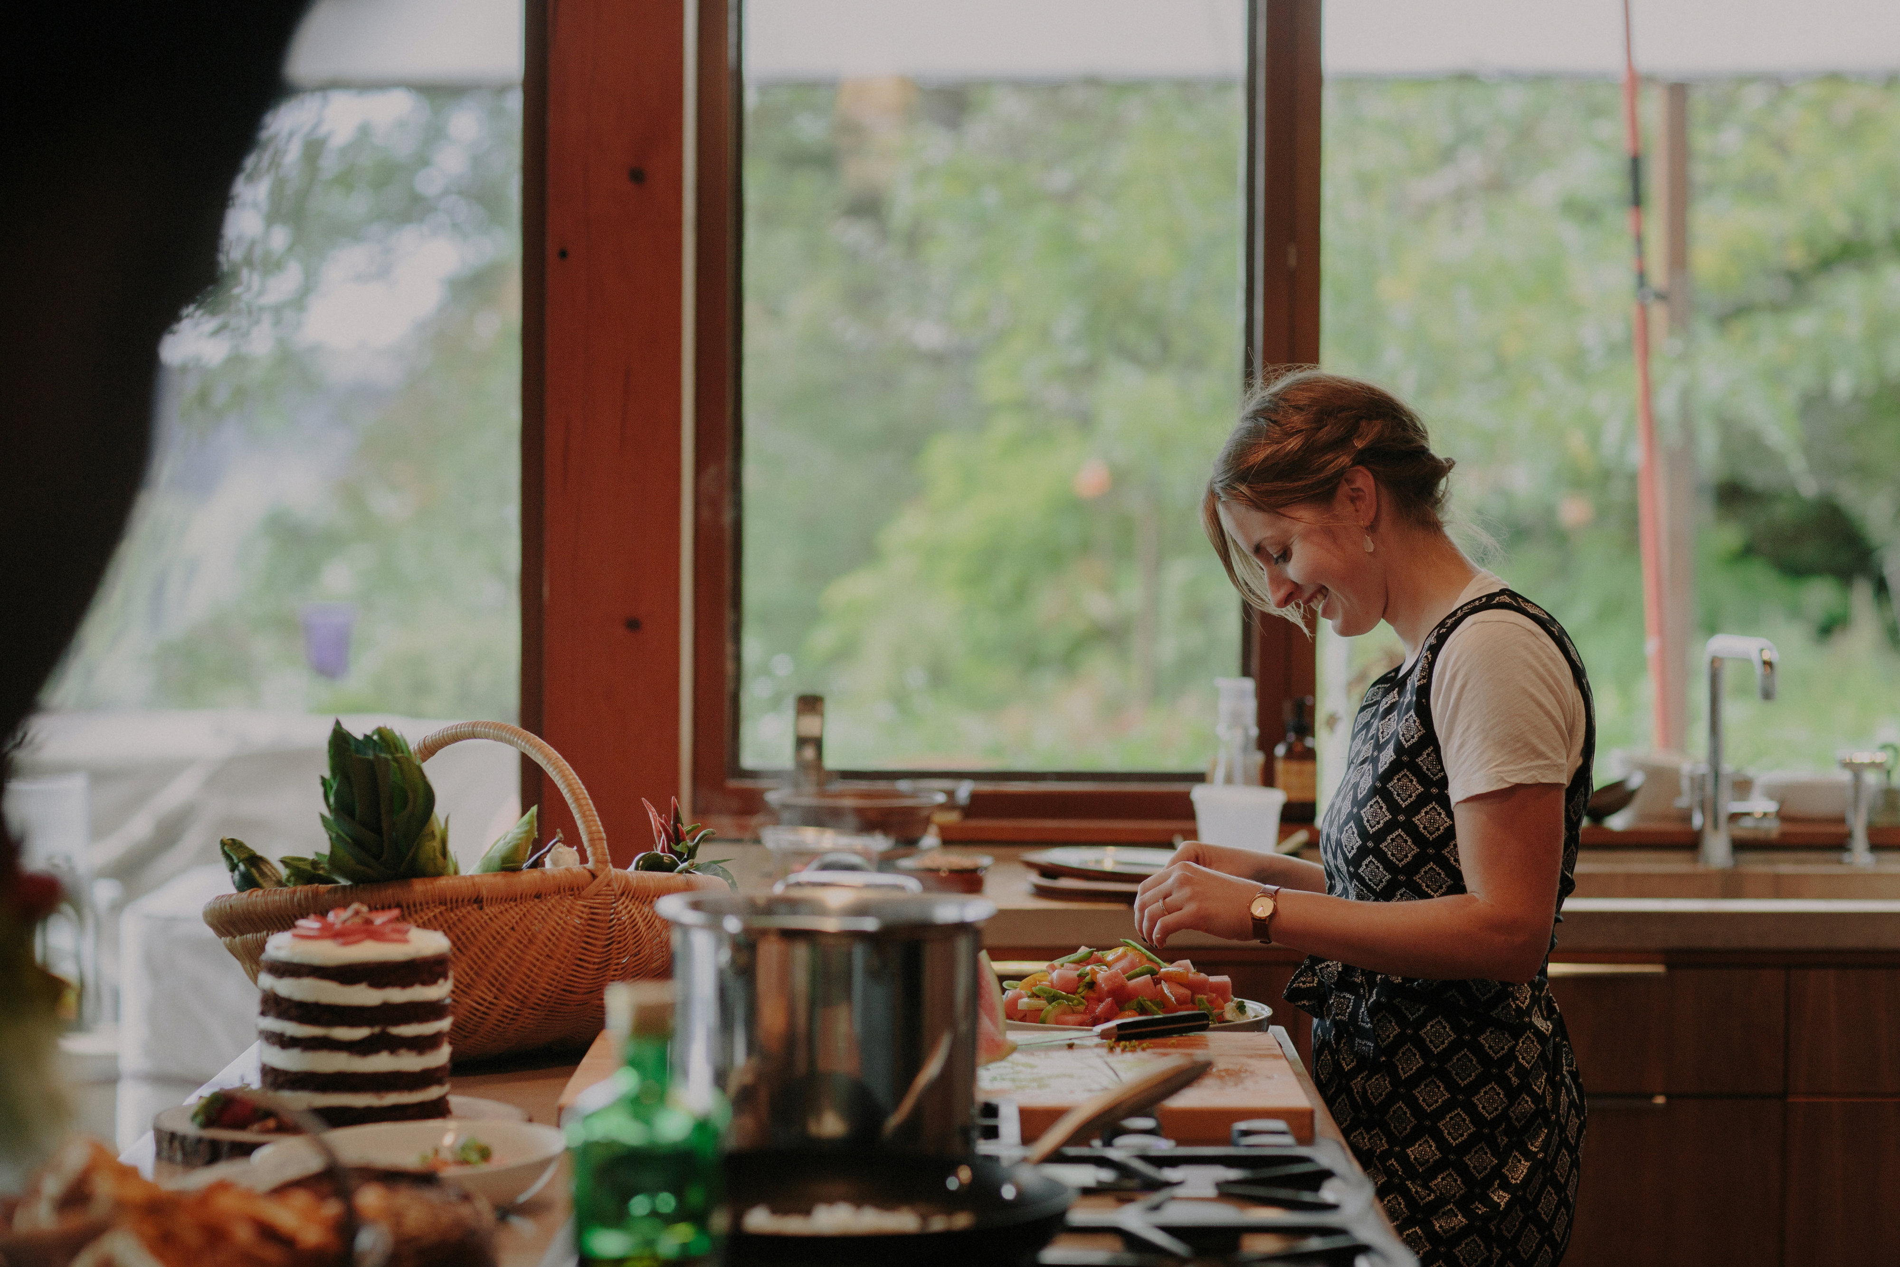

Emily is an Oregon native and professional chef, with 12 years experience cooking in some of Portland and New York’s best kitchens (Beast, Toro Bravo, Roberta’s & Blanca). Raised in Corvallis, Emily grew up working closely with her mother Kathy at a wholesale plant nursery in nearby Albany. It was there at the nursery, and in her family’s home garden that Emily came to understand delicious food as a product of quality ingredients. As an adolescent, her love for travel and dining introduced her to new food cultures and exotic cuisines around the globe, where she fell deeply in love with restaurants and hospitality at a young age. From Western Culinary Institute graduate (2003) to Iron Chef America contestant (Beast, 2010) - Emily’s culinary trajectory has found her leading the kitchens of some of Portland’s best chefs & restaurateurs; including Gabe Rucker & Naomi Pomeroy, Tommy Habetz, John Gorham, Troy McClarty, and more. Emily is currently finishing her last days of employment as the Chef de Cuisine at Cyril’s at Clay Pigeon Winery. She is inspired by local ingredients, seasonal vegetables & farm produce, and specializes in pastry, pies, and cakes.

**RYAN DOMINGO**

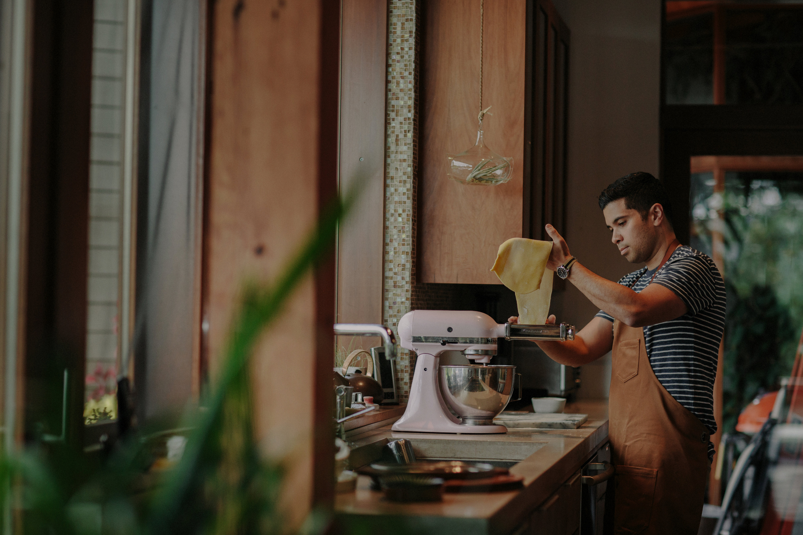

Ryan is a restaurant operations manager and chef, with experience in retail management, marketing & advertising. In 2004 he earned a degree in Marketing & Management from the University of Portland, where he also lettered four years as a member of the university’s Men’s Varsity Soccer Team. Ryan managed retail stores for Adidas and worked as an advertising account executive for Nike in his early 20’s. His love for food, cooking and dining inspired him to find work in restaurants in 2007. With 8 years experience in restaurant management, most notably as general manager of Andy Ricker’s Pok Pok Ny in Brooklyn, New York; Ryan has become an expert in restaurant systems, communication & team building, staff management, and guest relations. Ryan is currently employed as the Operations Manager of Ned Ludd & Elder Hall. In his spare time he is an avid forager and celebrates the bounty of the Pacific Northwest by the gathering of the seasons’ wild edibles. He is also the chef of a private, monthly Filipino supper club in Northeast Portland.

**LARCH FOOD**

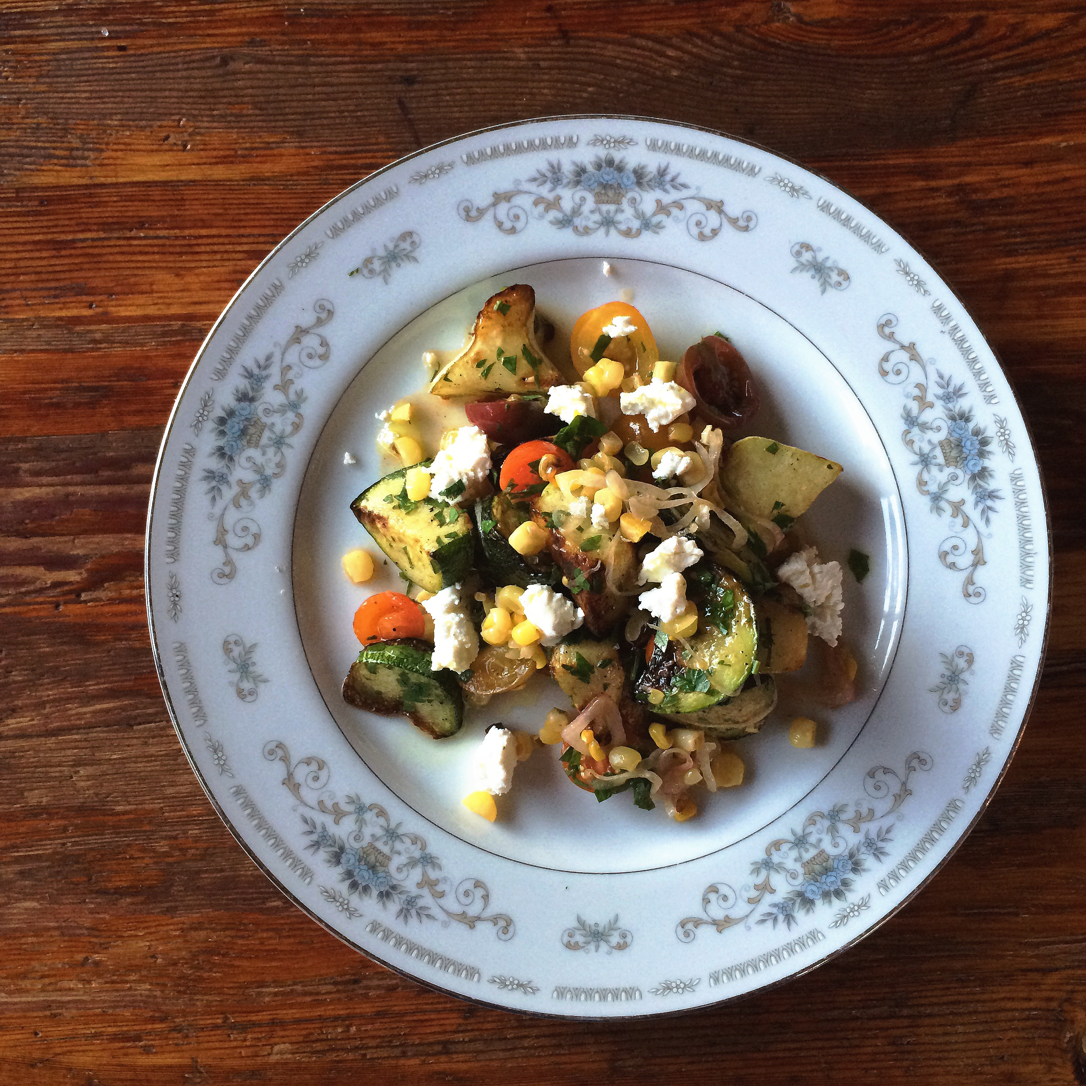

Roasted summer squash, sheep’s cheese, corn, sungolds and herbs

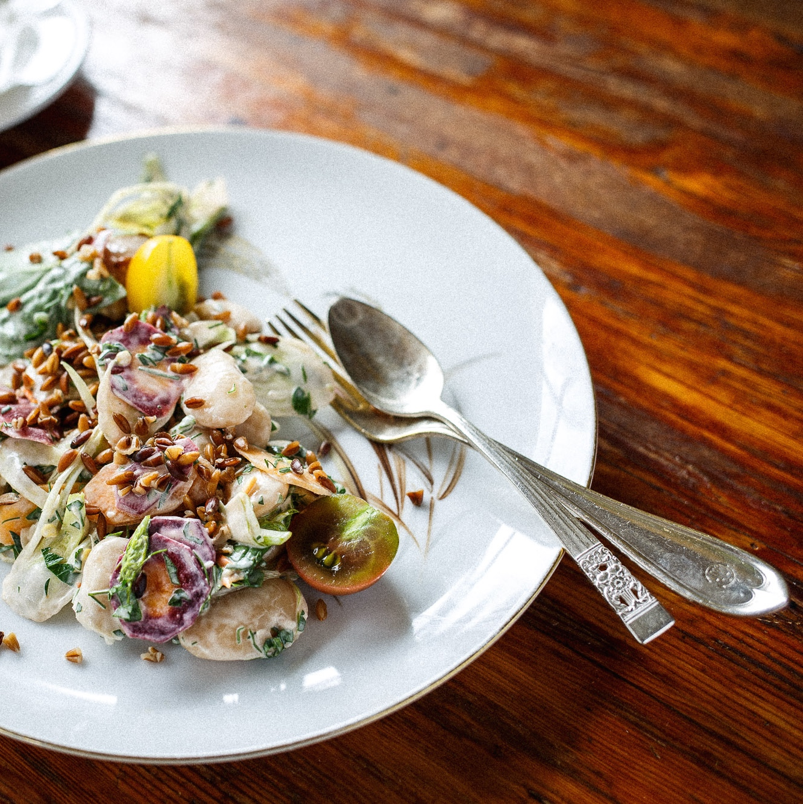

Butter beans, shaved fennel, tomato, farro and tahini vinaigrette

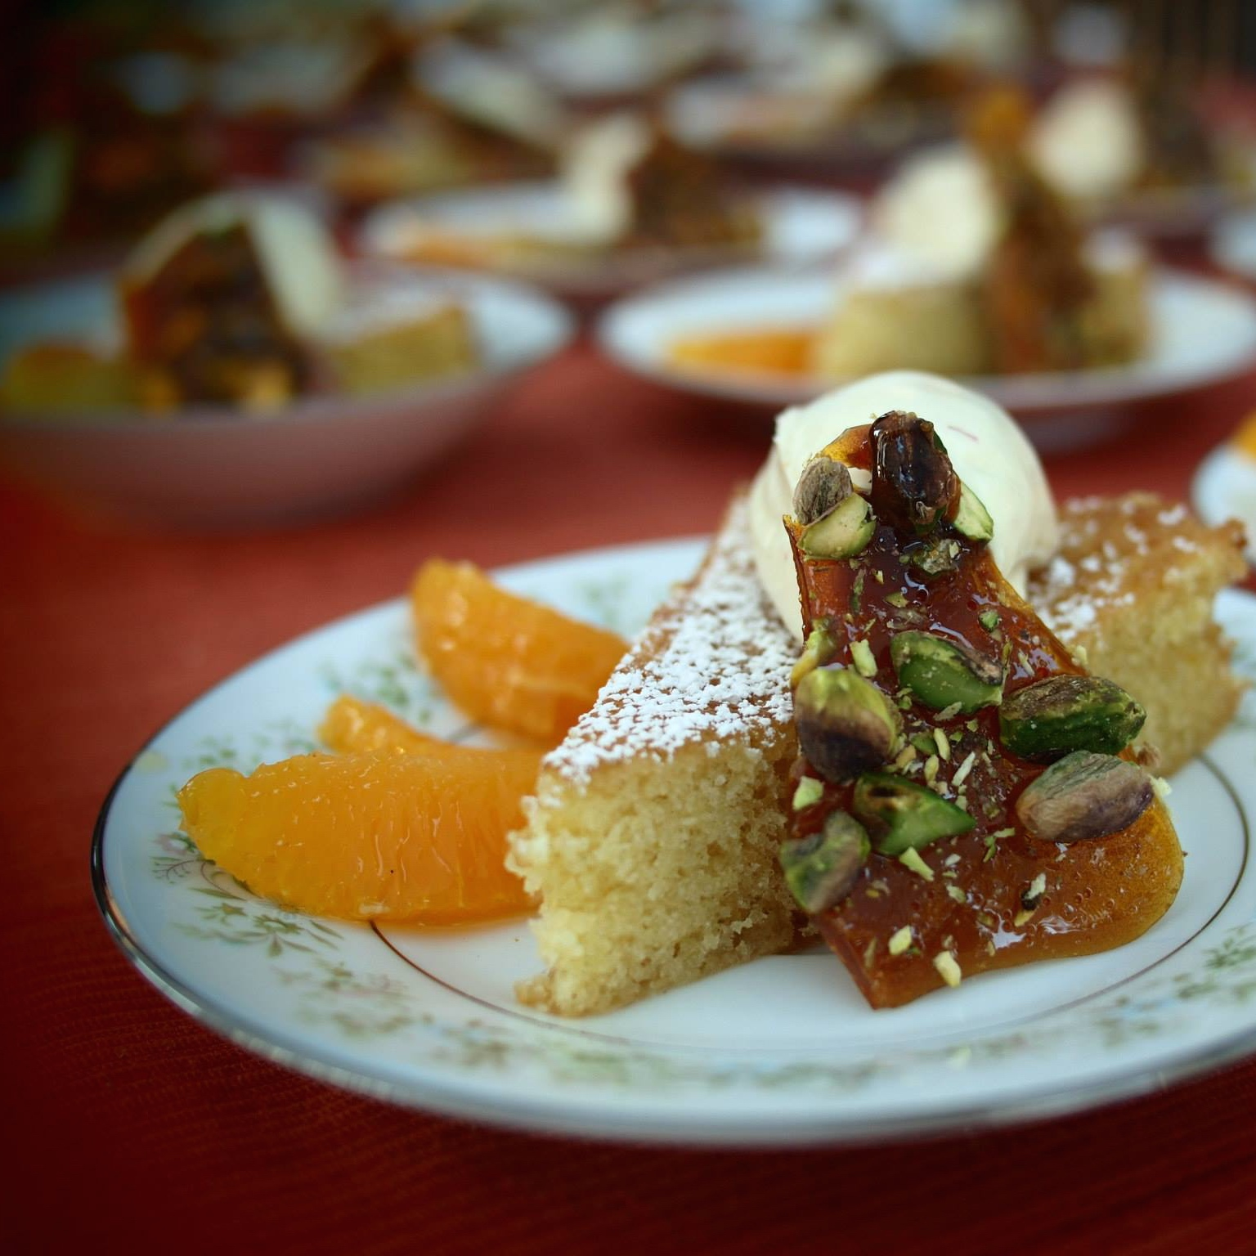

Olive oil cake, saffron cream, cara cara oranges and pistachio brittle

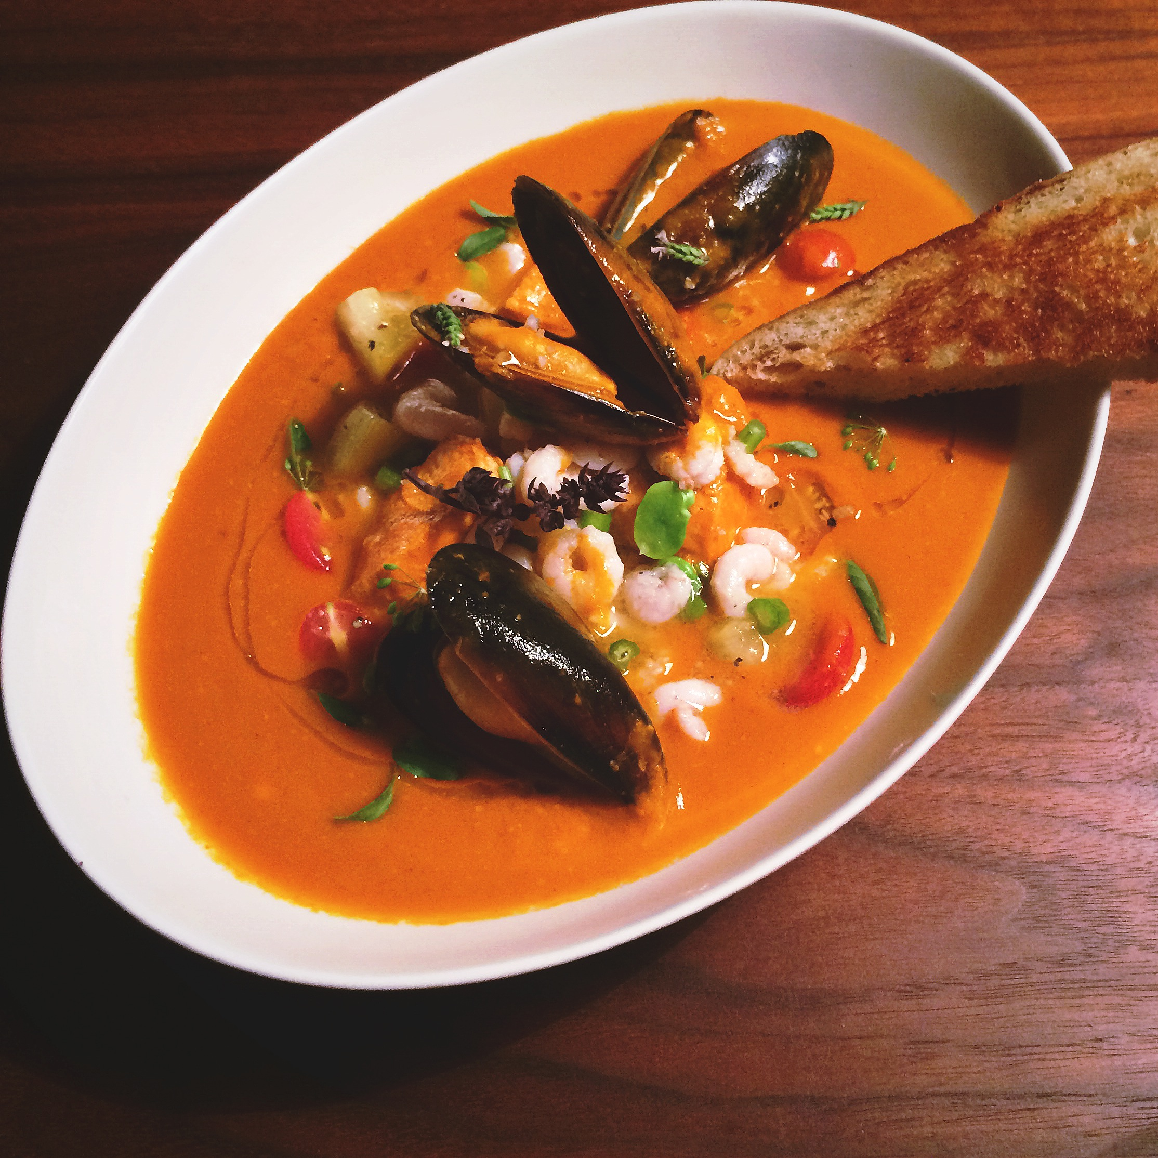

Ciopinno of Oregon bay shrimp, halibut, Prince Edward Island mussels with Hawaiian sweet bread

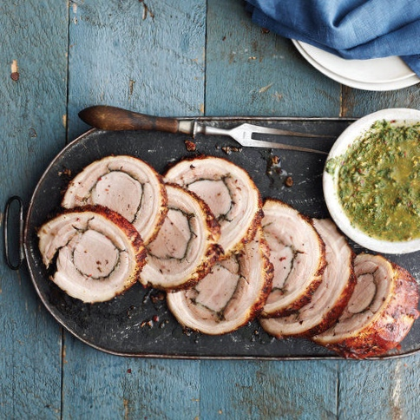

Stuffed porchetta and salsa verde

  
Wedding Cakes..

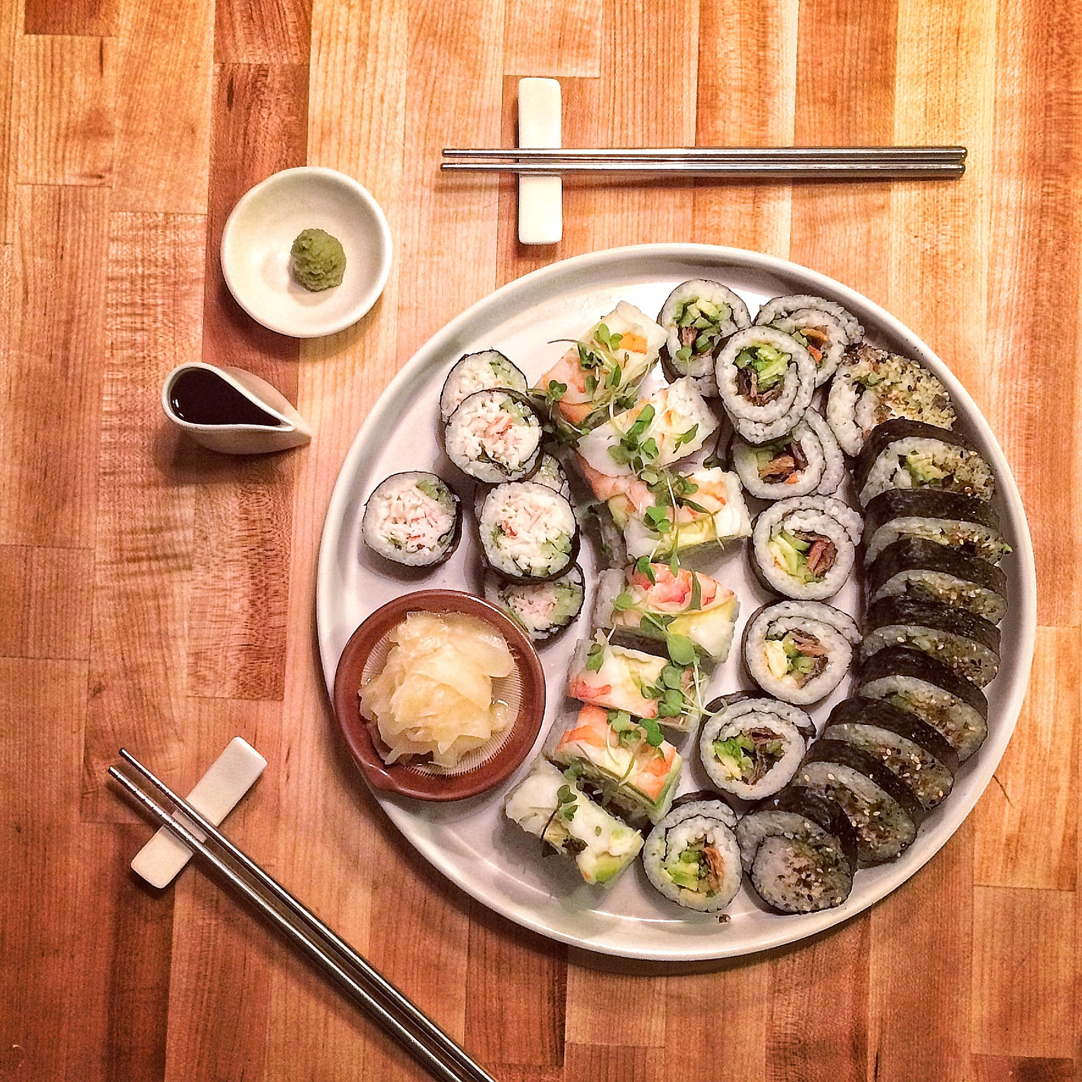

Assorted makimono sushi